Lista Final

# MER - SQL

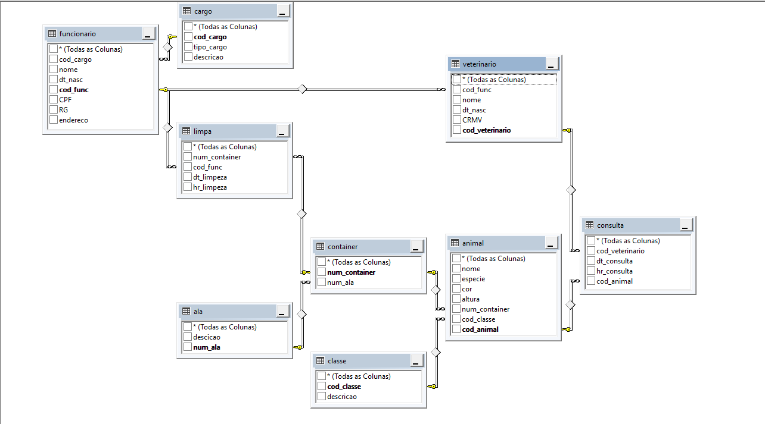

# MER e DER

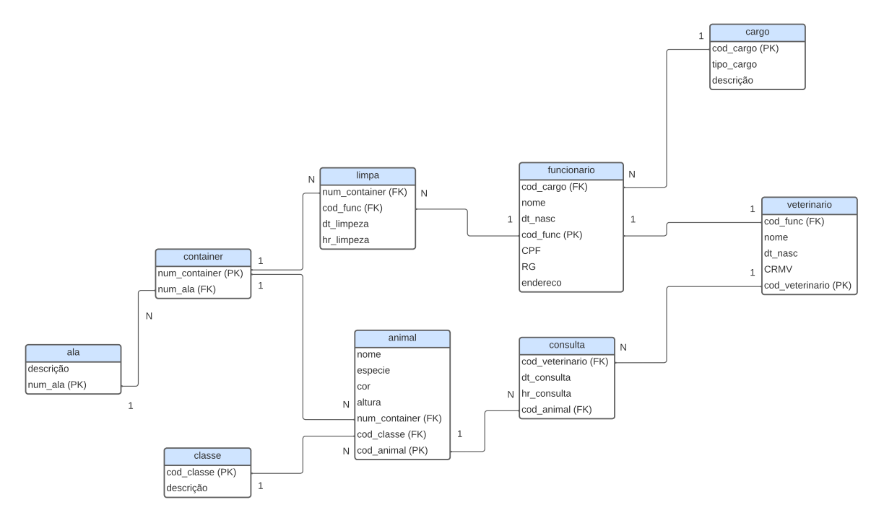

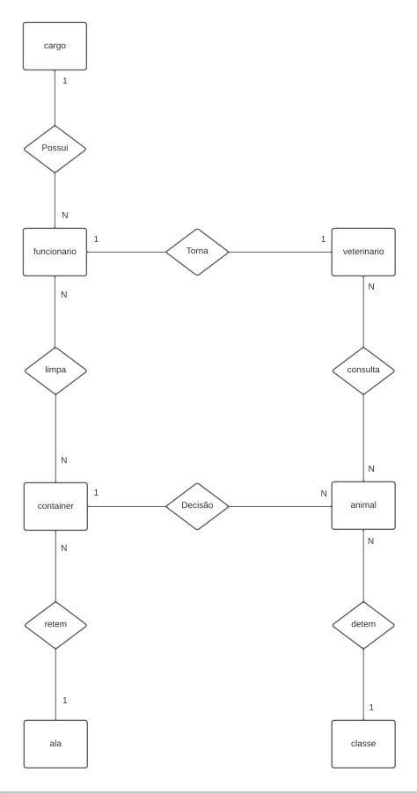

# Dicionário de Dados

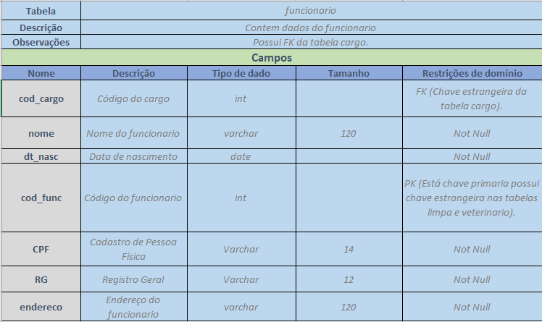

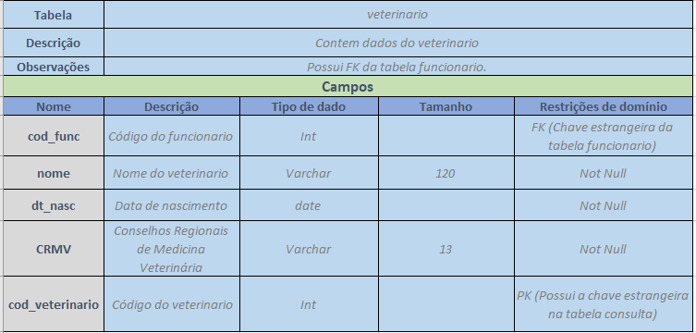

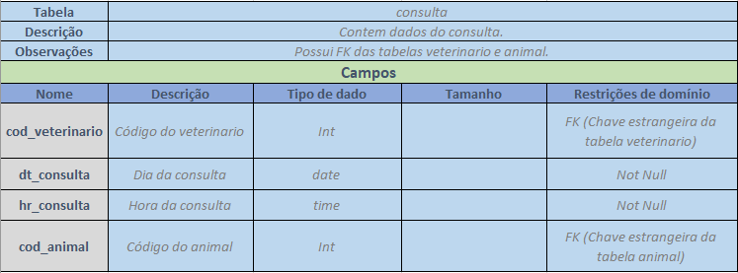

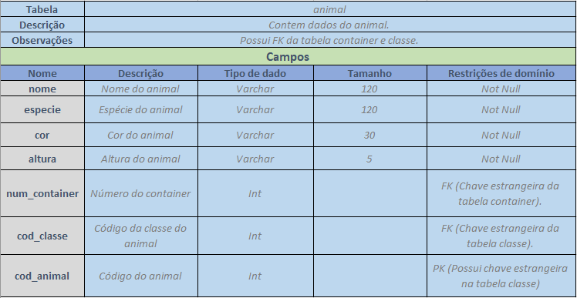

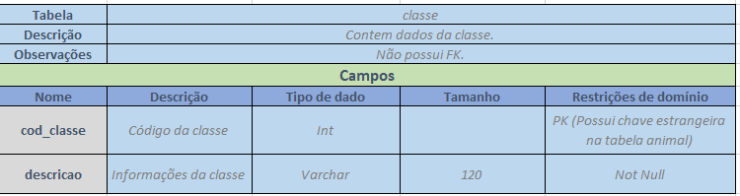

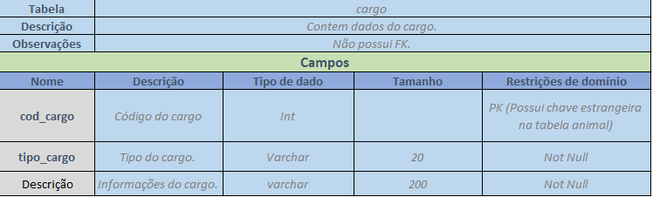

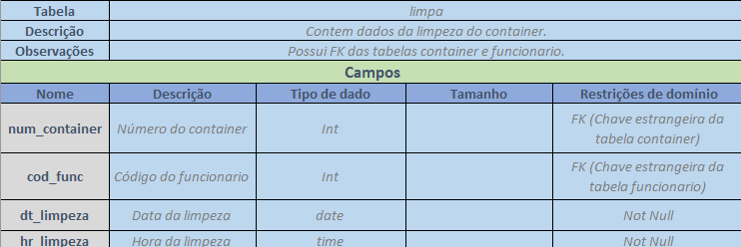

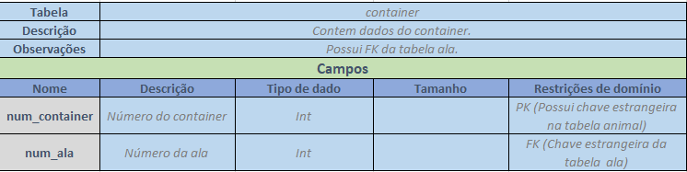

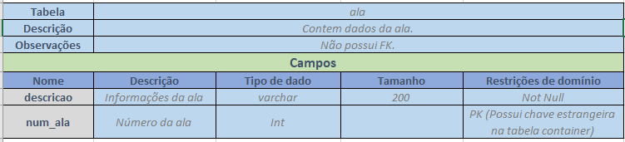

# Código fonte

create database bd_zoo;

use bd_zoo;

--- Tabela Funcionario

create table funcionario

(

cod_cargo int NOT NULL,

nome varchar (120) NOT NULL,

dt_nasc date NOT NULL,

cod_func int NOT NULL,

CPF varchar (14) NOT NULL,

RG varchar (12) NOT NULL,

endereco varchar (120) NOT NULL,

primary key (cod_func),

foreign key (cod_cargo) references cargo,

);

--- Tabela Veterinario

create table veterinario

(

cod_func int NOT NULL,

nome varchar (120) NOT NULL,

dt_nasc date NOT NULL,

CRMV varchar (13) NOT NULL,

cod_veterinario int NOT NULL,

primary key (cod_veterinario),

foreign key (cod_func) references funcionario

);

--- Tabela Conulta

create table consulta

(

cod_veterinario int NOT NULL,

dt_consulta date NOT NULL,

hr_consulta time NOT NULL,

cod_animal int NOT NULL,

foreign key (cod_veterinario) references veterinario,

foreign key (cod_animal) references animal

);

--- Tabela Animal

create table animal

(

nome varchar (120) NOT NULL,

especie varchar (120) NOT NULL,

cor varchar (30) NOT NULL,

altura varchar (5) NOT NULL,

num_container int NOT NULL,

cod_classe int NOT NULL,

cod_animal int NOT NULL,

primary key (cod_animal),

foreign key (num_container) references container,

foreign key (cod_classe) references classe

);

--- Tabela Classe

create table classe

(

cod_classe int NOT NULL,

descricao varchar (200) NOT NULL,

primary key (cod_classe)

);

--- Tabela Cargo

create table cargo

(

cod_cargo int NOT NULL,

tipo_cargo varchar (20) NOT NULL,

descricao varchar (200) NOT NULL,

primary key (cod_cargo)

);

--- Tabela Limpa

create table limpa

(

num_container int NOT NULL,

cod_func int NOT NULL,

dt_limpeza date NOT NULL,

hr_limpeza time NOT NULL,

foreign key (num_container) references container,

foreign key (cod_func) references funcionario

);

--- Tabela container

create table container

(

num_container int NOT NULL,

num_ala int NOT NULL,

primary key (num_container),

foreign key (num_ala) references ala

);

--- Tabela Ala

create table ala

(

descicao varchar (200) NOT NULL,

num_ala int NOT NULL,

primary key (num_ala)

);